951Quiz ee01 2006.09.25
1. A bar of silicon is doped with acceptors as known below. The doping density varies smoothly and monotonically in the direction from 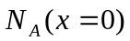 to 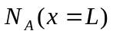, 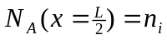. Around 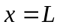 the acceptor profile becomes uniform. The donor density is zero everywhere. This is a thermal equilibrium situation.
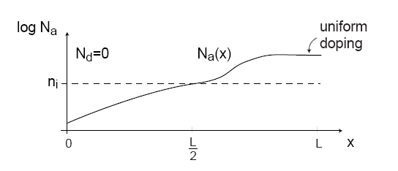
- Where is the hole concentration the greatest?

- Where is the electron concentration the greatest?

- In which direction does the hole diffusion current flow.

- In which direction does the electric field point?

- In which direction does the electron diffusion current flow?

- In which direction does the hole drift current flow.

- In which direction does the electron drift current flow?

- Where is the electrostatic potential the greatest?

- Sketch the volume charge density along x.

- Sketch the electric field distribution along x.

- Sketch the electrostatic potential distribution along x. Use as reference 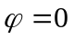 at 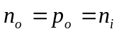.

2. (10%) A silicon junction diode with 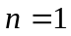has 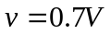, 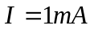 at 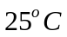. Find the voltage drop at 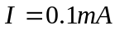and 

